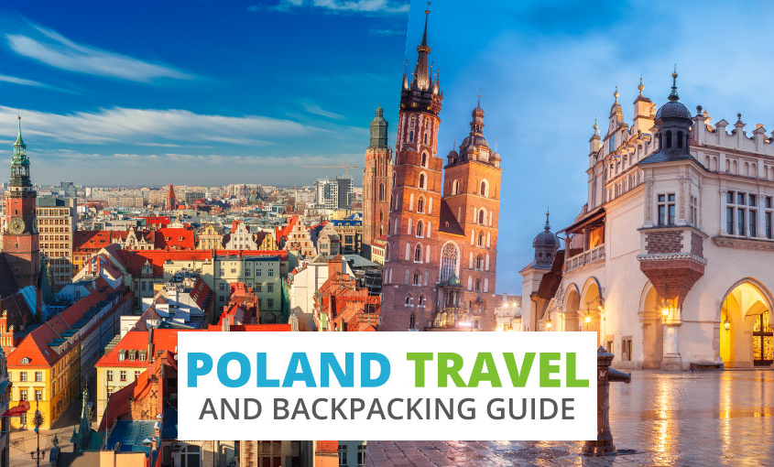
8/5/2020 – 08/16/2020

1 day 8/5/2020 Wednesday
Departure from St. Gabriel to Toronto airport by motorcoach.

2 day 8/6/2020 Thursday - WARSAW
Arrival in Warsaw. Transfer to Wilanów. Visit the palace in Wilanów - one of the most beautiful Polish royal residences that survived the partitions and wars without being destroyed. Transfer to the Temple of Divine Providence, which became thanksgiving for the Constitution of May 3, 1791. Transfer to the hotel, accommodation. Supper at hotel.

3rdday 8/7/2020 Friday WARSAW
Breakfast. A walk around Łazienki Królewskie, the most beautiful park in the capital. It was founded in the 18th century by King Stanisław August Poniatowski, where the famous statue of F. Chopin and the picturesque Palace on the Water. Visit the Warsaw Uprising Museum, opened on the 60th anniversary of the outbreak of insurgent fighting, one of the most modern museums in Poland. The museum is a tribute to those who fought for free Poland and Warsaw during World War II. A walk around the Old Town. Supper at hotel.

4th day 8/8/2020 Saturday – NIEPOKALANOW –CZĘSTOCHOWA
Breakfast. Transfer to Niepokalanów. Visit at the Franciscan monastery - sanctuary, founded by Father Maximillian Kolbe. Transfer to Częstochowa, where the Jasna Góra sanctuary and the Pauline monastery are located. The most important pilgrimage center in Poland, an important place of Marian worship with the miraculous image of Our Lady of Częstochowa. Mass. Transfer to Krakow. Hotel accommodation. Supper at hotel.

5 day 8/9/2020 Sunday - KRAKÓW - TYNIEC
Breakfast. Transfer to the Sanctuary of Divine Mercy in Łagiewniki. Mass and prayer in the chapel of the miraculous image of Merciful Jesus and Saint. Faustina. Transfer to the Benedictine Abbey in Tyniec. Visit the monastery located on the rocky bank of the Vistula. The Vistula valley gives way to the baroque church of St. Peter and Paul, the Benedictine monastery, and the courtyard. Opportunity to buy products based on religious recipes: jam, honey, cakes, sausages, cheese, wine, herbal teas and meads (honey liquors). Supper at hotel.

6 day 8/10/2020 Monday - KRAKÓW
Breakfast. Krakow sightseeing: Wawel Castle - seat of Polish kings from the 11th to the 17th century and the Wawel Cathedral. Walk through the Planty to the Bishop's Palace (park), where Pope John Paul II rested during all of his pilgrimages to Poland. Time for reflection at the famous Papal Window, from which the Pope greeted young people in unofficial, very cordial meetings and from where he said goodbye to them before leaving for the Vatican. Carriage ride around the Old Town. Walk: Main Square, Cloth Hall, St. Mary's Church with the Gothic altar of Veit Stoss. Free time for shopping. Supper at hotel.

7 day 8/11/2020 Tuesday - OŚWIĘCIM - WADOWICE - ZAKOPANE
Breakfast. Transfer to Oświęcim. Visit the former German Nazi concentration camp Auschwitz-Birkenau. Transfer to Wadowice - the hometown of Saint. John Paul II. Visit the family home of the great Polish Pope and the basilica of the Minor Offering of the Virgin Mary, where St. John Paul II was baptized. Transfer to Zakopane. Supper at hotel.

8 day 8/12/2020 - Wednesday ZAKOPANE
Breakfast. Stay in the capital of Podhale, a region located in the south of Poland with live folklore, original music, folk costumes and picturesque mountain tops. It was here that St. John Paul II often visited during his bishop's ministry, Cracow. Cable car ride to Gubałówka, from where there is a view of the beautiful panorama of the Tatra Mountains. Walk the famous Krupówki street with numerous shops and restaurants. Time for shopping at the Zakopane market with regional products. Stay in in the largest bathing pool with thermal waters in Podhale "Termy Chochołowskie". Over 30 pools, a medicinal zone with iodized brine, sulfuric water, hydromassage stands, and water geysers. There is the largest saunarium in Podhale with an impressive glazed - viewing sauna from which you can admire beautiful Tatra mountains. Supper at hotel.
9th day 8/13/2020 Thursday - ZAKOPANE - DUNAJEC rafting
Breakfast. Rafting on rafts through the picturesque, narrow mountain isthmus along the Dunajec River in the Pieniński National Park. Return to Zakopane. Time to relax. In the evening, dinner at a regional restaurant. Music provided by Highlanders and taste regional dishes. Back to hotel.

10 day 8/14/ 2020 Friday - WIELICZKA
Breakfast. Transfer to Wieliczka. Visit one of the biggest tourist attractions in Poland - the Salt Mine. The mine is on the UNESCO World Heritage list and is one of the oldest salt mines in the world operating continuously since the 13th century. A walk along the underground tourist route: underground pavements hollowed in salt, the chapel of St. Anthony, Chapel of St. Kinga with her relic. Transfer to Pilzno (father Joe’s hometown). Supper at hotel.

11 day 0/15/2020 Saturday - PILZNO
Breakfast. Participation at Mass combined with the sacrifice of harvest wreaths in Przeczyca (sanctuary Mather of Assumption. August 15 - Feast of the Mother of God and a day of gratitude for the harvest in Poland. Transfer to Tuchów. Prayer in the Basilica Visitation of the Blessed Virgin Mary and St. Stanisław, Bishop and Martyr. Visit the stable that consists of about 360 elements from figures dressed in regional and historical costumes. Return to the hotel. Time to relax. Farewell dinner.

12 day 8/16/2020 Sunday - RZESZÓW / ARRIVAL TO TORONTO
Breakfast. Mass. Transfer to the airport. Departure from Rzeszów at 2:55. Flight to Warsaw, then to Toronto. Arrival in Toronto at 8: 20 PM. Travel by motorcoach from Toronto airport to St. Gabriel

Cost: $ 3100 / person based on minimum group of 38 people).

Benefits included in the price:
- Motorcoach bus transportation from St. Gabriel to Toronto airport
- Round Trip Airfare
- Carryon luggage 8 kg. (18 lb.) and checked luggage 23 kg. (50 lb.) and meals during the flight.
- Tour Poland by motorcoach with guide
- 10 nights in hotels (rooms for 2-3 people with bathrooms)
- 10 breakfasts
- 10 dinners, including 1 with music in a regional restaurant
- Admission Tickets to Events – this cost of $200 (included in the $3100) is to be paid in cash to the tour guide

Please note: Proper attire requested for churches.

Deposit of $ 1200 due by January 8, 2020. Remainder of payment due by February 23, 2020.

