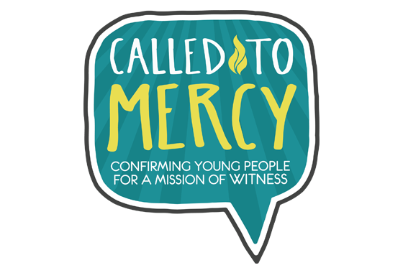

ST. GABRIEL CONFIRMATION
PROGRAM CALENDAR 2020/21
August 17, 2020

September 14 (Mon) Welcome video from Fr. Fred

September 20 (Sun) Student & Parent view on-line welcome and orientation at www.st-gabriel.org
- Introduce “Called to Mercy” Program - complete Module 1 by Sunday, September 27—prepares students for their conference!
- In the past, we’ve always begun our sessions with the 5 PM Sunday Mass. Although we can’t do that this year, we encourage students to attend their usual Mass with their families. For those that are not comfortable coming back to church just yet, we continue to offer Mass on line. Know that we will keep you in our prayers as we continue on this faith journey.
- Complete: Modules 2 & 3 by October 25; Modules 4-6 by December 6; Modules 7-10 by January 31.
- The Sacrament of Reconciliation will be offered every Saturday beginning at 3:45 PM in the Church. A Communal Penance Service is scheduled for December 14th beginning at 7 PM. We encourage each candidate to receive the Sacrament at least one time before being confirmed.

Week of Sun. Oct. 4 Individual Microsoft Teams Conferences with Student, Parent and Catechist – Catechist will contact
you to schedule.
Complete Modules 2 & 3 for October 25 MICROSOFT TEAMS ONLINE CLASS #1

October 25 (Sun) MICROSOFT TEAMS ONLINE CLASS #1 - Welcome to Confirmation Program 7-8:30 pm
- Discuss Modules 2-3
- Modules 4—6 completed by December 6; Modules 7-10 completed by January 31
- Reminder: Service Project due by February 14.

December 6 (Sun) MICROSOFT TEAMS ONLINE CLASS #2 - 7-8:30 pm
- Catechist to discuss Modules 4-6
- Discuss Saint Names for Confirmation. Please make sure you complete module 5 as
this module gives the information you need to complete Saint report due January 17.
- Modules 7-10 – need to be completed by January 31
- Information sheet, sponsor certificate, saint report, $60 fee are due January 17, 2021
- Discuss service projects/completion date of February 14.

January 17 (Sun.) Information Sheet, Sponsor Certificate, Saint Report, and Fee are Due

January 31 (Sun.) MICROSOFT TEAMS ONLINE CLASS #3 - Wrap up Meeting - 7-8:30 pm
- Discuss Modules 7-10
- Discuss service projects/completion date of February 14.

February 14 (Sun) At Home Service Project Report is Due
Week of Feb. 21 Final Individual MICROSOFT TEAMS Conferences with student and Catechists
March 1 (Mon) Practice for 2 pm Confirmation - 7:00 - 8:30 pm - Church - Candidate and Sponsor
March 2 (Tue) Practice for 5 pm Confirmation - 7:00 - 8:30 pm - Church – Candidate and Sponsor

March 7 (Sun) Celebration of Confirmation 2:00 pm and 5:00 pm

Green: MICROSOFT TEAMS Conference Meetings
Blue: MICROSOFT TEAMS Class Meetings
Purple: Student due dates

