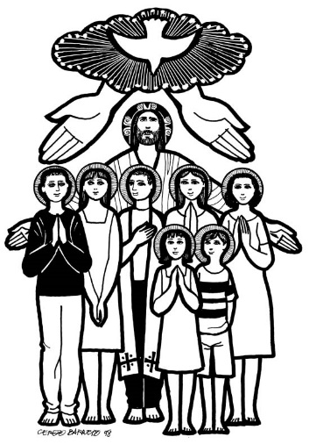
Called by Name …. Choosing A Confirmation Name … Your Saint Report
DUE SUNDAY, JANUARY 17, 2021
“Fear not, for I have redeemed you; I have called you by name: you are mine.” Isaiah 43.1
At the beginning of the Rite of Baptism, your parents were asked “What name do you give your child?” In the Rite of Confirmation, you are asked again to select a name. The Church encourages you to use the saint’s name given to you at Baptism as your Confirmation name to emphasize the strong connection between these two sacraments. However, that choice is yours. Whether you use your baptismal name or choose a new one, it is important to learn as much as you can about your patron saint.
Having models of holiness is very important in our culture in which movies, music, and sports heroes dominate our lives. Names of saints are chosen to serve as patrons and models for those being confirmed. Candidates should choose a patron saint’s name, not because it sounds nice, but because of the attractiveness of the Christian life that that person led. Below are a few examples.
- St. Andre of Montreal was a very pious man. He was a Brother in the Holy Cross order, the same order that founded Notre Dame University in Indiana and, more locally, Archbishop Hoban High School in in the Akron area. He often referred to himself as “St. Joseph’s little hound dog.” When people would come to him for prayer and healing, so often, through his own faith, through the help of St. Joseph and most importantly, by the power of God, many healings would in fact happen. Through his help and intercession, and that of St. Joseph, many people experienced miraculous healings, the majority of them occurring between 1880 and 1930. Many of these healings were unable to be explained scientifically. On October 17, 2010, Pope Benedict canonized this humble religious Brother Saint Andre Bessette of Montreal.
- Mother Teresa was always her own person, startlingly independent, obedient, yet challenging some preconceived notions and expectations. Her own life story includes many illustrations of her willingness to listen to and follow her own conscience, even when it seemed to contradict what was expected. The beatification of Mother Teresa was conducted on Oct. 19, 2003. A modern saint of our times.
Because Confirmation deepens the initiation begun at Baptism, it changes who you are forever. Because of this change, similar to how you have a middle name from Baptism, we ask you to pick another name for Confirmation. This name will be of a hero or heroine from the list of the Church’s canonized Saints to be your patron and your example for how you live out life as a confirmed Catholic follower of Jesus. Who is or will be your hero or heroine?
Please choose your hero or heroine and fill out and return the form about your Saint by Sunday, NOVEMBER 10
(see reverse side)
Before someone is known as “Saint,” they are also known as “Blessed.” This usually involves a Church-certified miracle through that person’s intercession, or help. People known as “Blessed” are fair game for your Confirmation name, too.
Here are some websites to help you: http://saints.sqpn.com/ http://www.catholic-saints.info/patron-saints/
http://www.americancatholic.org/features/saints/ Or just Google search “Saint” or “Blessed” and the thing you are looking for an example of.
OVER FOR SAINT REPORT – DUE DATE SUNDAY, JANUARY 17, 2021
SAINT REPORT
This Person is Heroic to Me Because…

My Name: ___________________________________________________________________________________
My Adult Group Leader: ____________________________________________________________________________
My Catholic Hero/Heroine’s Name: ___________________________________________________________________
Feast Day: _______________________________________________________________________________________
One or two heroic things this person did on earth:

This person is a patron or patroness of:

Interesting fact about this person:

What years or century this person was alive on earth:

As a Confirmed Catholic, I hope to live my faith like this person in these two or more ways:

Candidates’ full Confirmation name: ______________
Please return and complete this form no later than Sunday, JANUARY 17, 2021. Thank you!!!

